Ideation Phase
Brainstorm & Idea Prioritization Template
Date | 03 October 2026
Team ID | SWTID-2026-8647
Project Name | Implement Client Script & UI Policy (Incident)
Maximum Marks | 4 Marks

Brainstorm & Idea Prioritization Template:

This project applies ServiceNow client-side controls to improve Incident data quality. A UI Policy and UI Policy Actions dynamically control field behavior, while an onSubmit Client Script validates required values before save. The scenario focuses on Critical Incidents where Assignment Group and Short Description must be present.
The original template's three-step structure is retained: Step-1 selects the problem, Step-2 groups the solution ideas, and Step-3 prioritizes the implementation. Technical details are integrated into these steps.

Step-1: Team Gathering, Collaboration and Select the Problem Statement

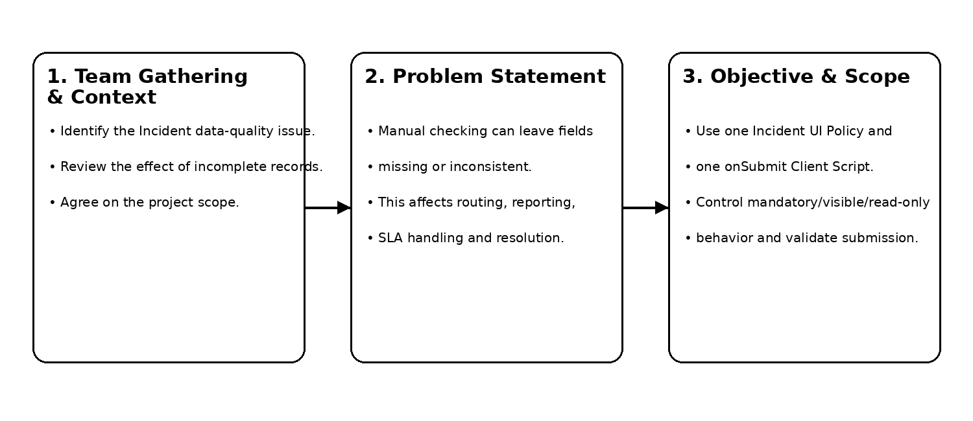

Project Title:

Implement Client Script & UI Policy (Incident).

Problem Statement:

Manual checking can leave Incident records incomplete or inconsistent, affecting triage, routing, reporting, SLA handling and resolution.

Objective:

Use UI Policies, UI Policy Actions and a Client Script to enforce conditional field behavior, validate data and improve consistency before submission.

Existing System:

Users depend largely on normal form entry and manual checks. Proposed System: Critical-Incident rules dynamically control mandatory, visible and read-only states and validate submission.

Scope:

Incident [incident], Priority/State conditions, one UI Policy, UI Policy Actions, one onSubmit Client Script, validation and evidence.

Tools:

ServiceNow, Incident Management, JavaScript, UI Policies, UI Policy Actions, Client Scripts and GlideForm (g_form).

Step-2: Brainstorm, Idea Listing and Grouping :

The solution ideas are grouped into platform concepts, UI behavior, validation logic and project evidence.

Idea Group | Included Concepts
Platform & Incident | ServiceNow Platform; Incident Management; Incident [incident]; Priority; State
UI Behavior | UI Policy; UI Policy Actions; mandatory; visible; read-only; dynamic field behavior
Validation | Client Script; onSubmit; g_form.getValue(); g_form.addErrorMessage(); return false/true; value setting
Evidence | Implementation steps; testing; screenshots; advantages; limitations; future enhancements; references

UI Policy Configuration :

Property | Configuration
Name | Critical Incident Data Quality Control
Table | Incident [incident]
Condition | Priority = 1 - Critical AND State is not Closed
Active / Reverse if false / On load | True / True / True

UI Policy Actions :

Field | Mandatory | Visible | Read-only | Reason
Assignment group | True | True | False | Required routing for Critical Incidents.
Short description | True | True | False | Required summary of the problem.
Priority | Leave alone | True | True | Prevents accidental change after Critical selection.
Business service | Leave alone | True | Leave alone | Keeps service context visible.

Client Script Configuration :

Property | Configuration
Name | Validate Critical Incident Before Submit
Table / Type | Incident [incident] / onSubmit
UI Type / Application | Desktop / Global
Active | True
Purpose | Validate Critical Incident values and block invalid submission.

Auto-population option:

If the course configuration requires a value to be set automatically, an additional line can set State before submission. Because State choice values can vary by instance, verify the target instance's internal values before enabling such a line.

Implementation Steps :

1. Open the ServiceNow instance.
2. Navigate to the Incident module.
3. Confirm Priority, State, Assignment Group, Short Description and Business Service.
4. Create the UI Policy.
5. Configure the Priority/State condition. 6. Create the UI Policy Actions.
7. Create the onSubmit Client Script.
8. Add and save the validation logic.
9. Save and test the configuration.
10. Verify normal and Critical Incident behavior and capture actual evidence.

System / Workflow Architecture :

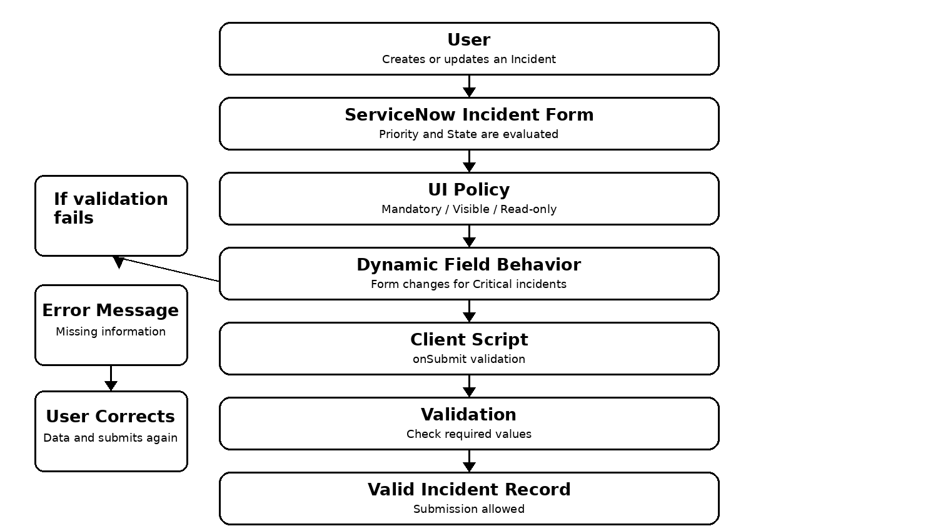Step-3: Idea Prioritization

Functional Requirements :

1. Create Incident records.
2. Dynamically control fields with UI Policies.
3. Make specified fields mandatory under defined conditions.
4. Control visibility.
5. Control read-only behavior.
6. Validate Incident data with Client Scripts.
7. Prevent submission when required information is missing.
8. Display appropriate validation messages.

Non-Functional Requirements :

Requirement | Explanation
Usability | Clear field behavior based on Priority and State.
Reliability | Validation should consistently run on the configured form.
Maintainability | Keep UI configuration declarative and script logic small.
Performance | Use simple client-side checks; avoid unnecessary server calls.
Data consistency | Critical Incidents contain routing and description information.
Security | Client-side controls are not a replacement for ACLs or server-side controls.
Ease of configuration | Rules can be changed through standard ServiceNow records.

UI Policy + Client Script Relationship :

UI Policy controls Mandatory, Visible and Read-only behavior through configuration. Client Script performs field-value checking, dynamic processing, messages, optional value setting and save-time validation. Together, the UI Policy guides the user and the onSubmit Client Script performs an additional client-side validation check before submission.

Testing Procedure and Test Cases :

ID | Scenario | Input / Condition | Expected | Actual | Status
TC-01 | Normal priority | Priority not Critical | Critical-only policy does not apply. | To be verified | Pending
TC-02 | Critical priority | Priority 1; State not Closed | Assignment Group and Short Description mandatory; Priority read-only. | To be verified | Pending
TC-03 | Required field empty | Critical; Assignment Group empty | Error displayed; submission blocked. | To be verified | Pending
TC-04 | Required fields filled | Critical; required values present | Validation passes; submission allowed. | To be verified | Pending
TC-05 | Policy condition true | Critical + not Closed | UI Policy Actions apply. | To be verified | Pending
TC-06 | Policy condition false | Not Critical or Closed | Actions reverse because Reverse if false is enabled. | To be verified | Pending
TC-07 | Client validation | Critical with missing value | Error message and return false prevent submission. | To be verified | Pending
TC-08 | Valid submission | All required values present | Incident can be submitted; verify record in instance. | To be verified | Pending

Advantages :

Improves Incident data quality; reduces incomplete records; provides immediate user feedback; reduces manual validation; improves consistency; supports Incident Management; makes the form more user-friendly.

Limitations :

Client-side validation can be bypassed in some situations; correct ServiceNow configuration is required; field-name or business-rule changes may require updates; Client Scripts primarily control client-side behavior.

Future Enhancements :

Additional validation rules; advanced Incident conditions; automated notifications; integration with assignment rules; additional UI Policies; server-side validation where appropriate; improved reporting and monitoring; more data-quality controls.

Conclusion :

This project demonstrates how ServiceNow UI Policies, UI Policy Actions and Client Scripts can work together to improve Incident form behavior and data quality. The UI Policy provides conditional field control for Critical Incidents, while the onSubmit Client Script checks required values and prevents invalid submission. The design uses standard configuration and simple JavaScript suitable for a Skill Wallet student project.

